A’s no-arg Constructor is invoked A doesn’t have a default constructor

this.length= length



Super(radius) instead of Circle(radius)



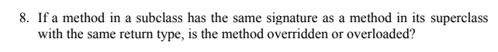

**-overridden**

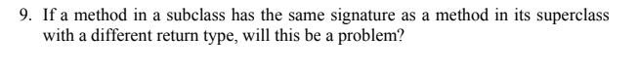

**-Yes, Syntax error.**